IRELAND
Discover an island paradise that boasts everything from a thrilling cultural voyage to nature’s glorious wonderland. With the history of Ireland dating back as far as 6000BC, the past has truly paved the way for the island’s buoyant present and future. What separates Ireland from its neighbours is the arresting beauty of the land, the turbulent history of the island, the broad smile that welcomes your arrival and the heartfelt farewell that signals your departure. Discover Ireland, it's yours to enjoy

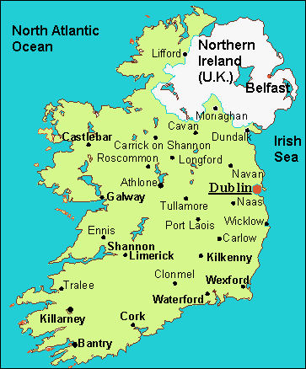
Athlone | Belfast | Carlow | Castlebar | Cavan | Cork | Dublin | Galway | Killarney | Kilkenny | Limerick | Rosslare | Sligo | Waterford
Athlone | 135 | 222 | 110 | 125 | 81 | 180 | 110 | 93 | 231 | 122 | 147 | 198 | 224
Belfast | 260 |  | 251 | 284 | 141 | 191 | 329 | 312 | 471 | 289 | 365 | 332 | 465
Carlow | 244 | 251 |  | 231 | 189 | 337 | 185 | 201 | 233 | 38 | 150 | 88 | 250
Castlebar | 38 | 284 | 231 |  | 169 | 148 | 141 | 87 | 291 | 247 | 179 | 375 | 284
Cavan | 172 | 141 | 189 | 169 |  | 118 | 189 | 172 | 309 | 200 | 226 | 267 | 302
Cork | 312 | 422 | 186 | 278 | 297 | 394 | 138 | 203 | 87 | 147 | 100 | 193 | 119
Dublin | 238 | 167 | 86 | 250 | 124 | 259 | 232 | 215 | 305 | 123 | 199 | 152 | 299
Galway | 120 | 312 | 201 | 87 | 172 | 203 | 66 |  | 217 | 194 | 105 | 301 | 210
Killarney | 201 | 471 | 233 | 291 | 309 | 406 | 149 | 217 |  | 194 | 111 | 261 | 33
Kilkenny | 256 | 289 | 38 | 247 | 200 | 301 | 167 | 194 | 194 |  | 130 | 90 | 230
Limerick | 212 | 365 | 150 | 179 | 226 | 294 | 37 | 105 | 111 | 130 |  | 196 | 105
Rosslare | 332 | 332 | 88 | 375 | 267 | 418 | 234 | 301 | 261 | 90 | 196 |  | 296
Sligo | 59 | 201 | 227 | 83 | 114 | 65 | 193 | 138 | 340 | 239 | 230 | 315 | 335
Waterford | 337 | 326 | 74 | 304 | 249 | 350 | 163 | 231 | 190 | 48 | 126 | 72 | 225
Distance between cities in Ireland
Driving time
From | To | Distance | Driving Time
Belfast | Limerick | 316kms | 4h 8
Cork | Belfast | 410kms | 5h 3
Dublin | Cork | 253kms | 3h 9
Dublin | Galway | 209kms | 3h14
Malin Head | Mizen Head | 593kms | 9h 8
Rosslare | Cork | 193kms | 3h06
Sligo | Rosslare | 308kms | 4h7

VISA The visa is to be obtained prior to arrival in the country

Getting There

INTERNATIONAL AIRPORT:
Ireland has 4 International Airports and 7 regional airports
Dublin International Airport | north of Dublin City Centre. It is situated near the M50 and M1 motorways.
Belfast International Airport - | 20 min from city centre by car
Donegal regional Airport - | situated at Carrickfinn, Kincasslagh, approximately 15 mins .
Kerry International Airport | 15 min. from Killarney & the Ring of Kerry & 20 min from Tralee.
Cork International Airport | Less than 10 min. from City Centre
Galway Airport
Shannon Airport
Sligo Regional Airport
Waterford Regional Airport
Ireland West Airport Knock
DerryAirport

CURRENCY:
Euro is the official of Republic of Ireland and Pounds in Northern Ireland

CLIMATE
The climate of Ireland is dominated by the prevailing warm, moist winds from the Atlantic Ocean. It's known as the Emerald Isle because of its striking verdant landscape, due entirely to the temperate climate and rainfall. Ireland has mild winters, and cool summers. May to September is the warmest and driest seasons of the year. Winter consists of short, wet, foggy days, and long nights. The best time to grow crops is around May to July. Whale season is in July. The best time to visit is August.

TIME:

Italy is 5 hours and 30 minutes behind India.

CLOTHING:
Lightweight woollen and cotton clothes are suitable in summer, with thicker wool sweaters or jacket for spring and autumn days. Although public buildings are centrally heated, indoor temperatures are lower than those in the US and Canada. Pack a raincoat and sweaters, whatever the season, and comfortable shoes for sightseeing.

ELECTRICITY:
The voltage used is 240 volts.

DAILING CODE:
+ 353

TIPS:
At a restaurant check your bill to see if service is included. It usually is. If not and if you are satisfied with the service, pay 10-15 per cent as a tip. In hotels, the tip works out at about 50p per bag for the porter. It is customary but not obligatory

Language:
The main language spoken on the island of Ireland is English

Shopping :
Shops in Belfast city centre are open 9am-5:30pm Mon-Sat, later on Thursdays. Most other towns close half-day on one day a week (different from town to town) and small shops tend to close at lunchtime. Some large shopping centers on the outskirts of town stay open until 9pm. Many towns have a market once a week.

Cities:
As well as being hip, vibrant and cosmopolitan, Ireland’s 11 urban hubs are perfectly formed – not too big to be overwhelming, and not so small that you can see it all in a day!

Dublin
Ireland has two capital cities. The capital of the Republic of Ireland, Dublin is one of Europe’s coolest capital cities. The city pulsates with energy thanks to its excellent restaurants, chic boutiques, legendary pubs, beautiful art galleries, verdant urban parks, elegant architecture, fascinating and turbulent history, plus its unique scenic location perched at the edge of the Irish Sea.

To get there:
Dublin is extremely accessibly by air.
Bus: there are 2 types of bus transport back to the city: a blue Air coach express service connects to the city centre and many Dublin major hotels & takes approx 30 min.
Taxi: a taxi to city centre cost approx. Euro 25 to 30.
Train: Dublin has 02 main train stations: Heuston and Connolly
Getting there:
Ireland is accessible by air, with over 30 airlines flying routes from more than 70 destinations. Important Airports are Belfast City and International airports, Cork International, Dublin amongst others.

Regions in Briefs:
Ireland is divided into four historic provinces – Ulster, Munster, Leinster and Connacht- 32 countries, of which 26 are in Republic of Ireland and 6 in Northern Island.

Getting Around:
Car Rental:
It is the best way to experience the spectacular scenery of this country. Driving in Ireland is on the left which is same as India
Inland Ferries and Island boat services:
Regular boat services operate to the various islands in Ireland and also several Inland ferries ease the transportation. The three main water ways of cruising are the River Shannon, the Grand Canal and the Erne Waterway System. Ireland has 6 main ferry ports- Belfast, Cork, Dublin port, Dun Laoghaire, Larne and Rosslare.
Taxis: There are metered taxis in Belfast, Cork, Dublin, Galway and Limerick.

Climate:
Ireland has a mild temperate climate with summer temperatures generally ranging from 15 degree Celsius to 20 Degree Celsius. Temperatures in spring and autumn are generally 10 Degree Celsius. In winter 4 to 10 degree Celsius, snow is rare occurrence. However showers can occur at any time of the year.

Shopping:
Waterford Crystal, Bushmills Wiskey, Irish Lenin, Blarney, Avoca Wollens, Belleek Pottery, Guiness Beer.

Attractions

Christ Church Cathedral:
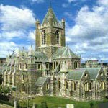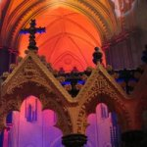
This exceptional cathedral dates back to around 1030. The crypt, which dates back to 1171-2, is one of the largest medieval crypts in Ireland and the UK, Christ Church Cathedral is one of Dublin's oldest and most recognized landmarks. Dating back to the eleventh century, the Cathedral and the exhibition "Treasures of Christ Church" reflect 1000 years of history, architecture and worship in Ireland. Treasures of Christ Church display a unique range of manuscripts, historic artifacts and spectacular examples of gold and silverware. Christ Church Cathedral holds a series of concerts, recitals and talks every year. Address: Christchurch Place, Dublin City Centre, County Dublin, Dublin 8, Republic of Ireland. Opening Hours: Mon- Fri: 9.45am to 5 pm and Sat- Sun: 10.00 am to 5 pm
Top of Form
Bottom of Form

Custom House

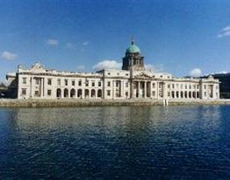
No view of Dublin's skyline is complete without a tableau of the old Georgian Custom House, which is considered to be architecturally the most important of Dublin’s buildings. The Custom House, designed by the renowned James Gandon, was completed in 1791 and is one of Dublin's finest heritage buildings. It has played a unique role in Dublin's social, economic and political history over the past 200 years. The Visitor Centre is located in and around the Dome or Clock tower area which contains the most important interior features to have survived the destruction of the building by fire in 1921, during the War of Independence. Direction: 5 minutes walk from O' Connell Bridge (near to Busaras) across the Quay from Tara Street Dart Station. Address: Custom House Quay, Dublin City Centre, County Dublin, Dublin 1, Republic Of Ireland

Dublin Castle

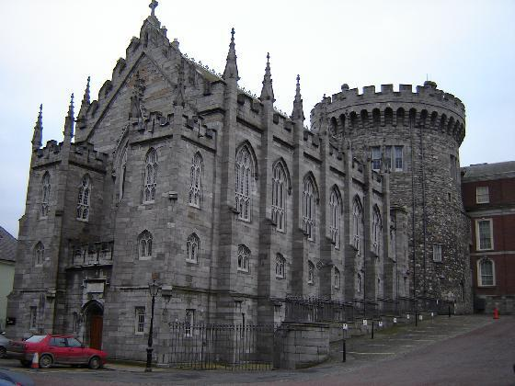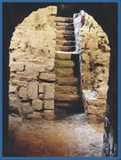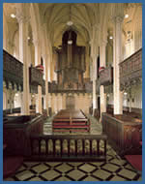
Under Croft The chapel Royal
Dublin Castle is more of a palace than a castle and is currently used to entertain heads of state. Guided tours of the State Apartments, the Chapel Royal and the Under croft, where the ancient city walls join the castle, are available. Opening Hours Monday-Friday, 10.00hrs. - 16.45hrs. Saturday, Sunday Public Holidays, 14.00hrs. - 16.45hrs. Closed; Good Friday, 25th-26th December, 1st January. Location: Dublin Castle is situated in the very heart of Dublin City, on the south side of the River Liffey, off Dame Street, en route from Trinity College to Christchurch Cathedral. Dublin Castle is situated in the very heart of Dublin City, on the south side of the River Liffey, off Dame Street, en route from Trinity College to Christchurch Cathedral.

Guinness Storehouse
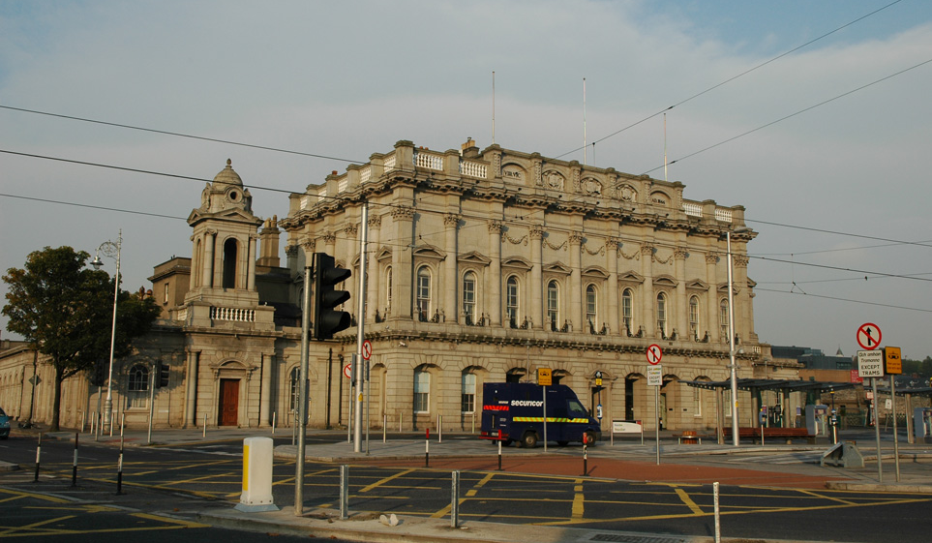

The air around the Guinness Storehouse offers a fascinating insight into 250 years of brewing history. The tour finishes up with a complimentary pint in the spectacular 360degree Gravity Bar. Ireland is rightly famed for Guinness and a visit to the Storehouse in James’s Gate. Whiskey drinkers will find Ireland is a joy as Irish whiskey is distilled three times, unlike Scotch, which is only distilled twice. You can learn all about Irish Whiskey at the numerous whiskey distilleries around the country, the most famous being, the Old Middleton Distillery in Cork, the Old Jameson Distillery in Dublin, and the Bushmills Distillery in Antrim. Opening Hours: Daily 9.30am – 5pm (last admission is at 5pm)
Late opening during July and August until 7pm (last admission is at 7pm) . * Closed Christmas Eve, Christmas Day, St. Stephen's Day (Boxing Day) and Good Friday. Normal opening hours are in operation on Bank holidays To get there:the best way to get to GUINNESS STOREHOUSE® from the city centre is on foot. Journey time 15 mins. By car: 5min. By Bus: Bus 51B from Aston Quay runs every 15 mins. Journey time 10 mins. Bus 78A from Aston Quay runs every 8-10 mins. Journey time 10 mins. Bus 123 from O'Connell Street runs every 8-10 mins. Journey time 10 mins. Bus 123 from Dame Street runs every 8-10 mins.

Malahide Castle
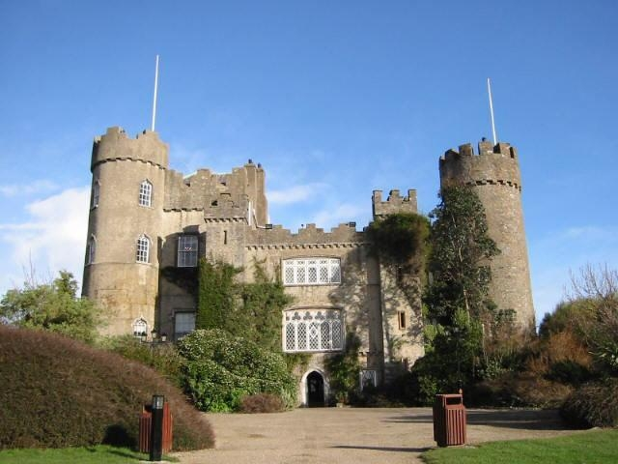
Set on 250 acres of parkland, Malahide Castle was both a fortress and a private home for nearly 800 years and is an interesting mix of architectural styles. The house, which has been the home of the Talbot family from 1185 till 1973, is an interesting mix of architectural styles. Furnished with beautiful period furniture, it is home to an extensive collection of Irish paintings, mainly from the National Gallery, the family portraits in particular telling their own story of Ireland’s turbulent history. The tearooms and coffee shop offer you an old style surrounding, with the facilities of a modern self–service area. Here you will find a selection of full meals, light snacks, salad bar, desserts, tea, coffee, wines and other refreshments, all of which are reasonably priced.
To get there: Directions: No. 42 bus from the City Centre, No. 230 from Dublin Airport and No. 102 bus from Sutton. The Dublin to Drogheda train and the Dart serve Malahide Town, a walk of only minutes to a Park entrance.Location: Malahide Castle, Malahide, Dublin North, County Dublin, Republic Of Ireland Opening Hours: Mon-Sat 10 am-5.00 pm, April to Sept Sun & public holidays 10 am – 5 pm

Old Jameson Distillery
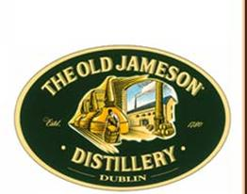
Nestling in the heart of old Dublin lies the old Jameson Distillery, with origins dating back to 1780. Tours are available. Old Jameson Distillery in Smithfield Village is in the heart of Old Dublin. Irish whiskey can trace its history back to the 6th century. Almost like a tour of a working distillery you can follow the fascinating craft of whiskey making through the different stages from grain intake to malting, mashing, fermentation, distillation, maturation and bottling. Finally the tour culminates in the Jameson bar for a traditional Irish Whiskey tasting session. Other facilities include Distillery Gift Shop and Restaurant. Opening Hours: The Old Jameson Distillery is open 363 days a year. The first tour commences at 9:30am and tours run until 5:30pm. The Gift shop and the Stillroom restaurant open from 9:30am until 5:30pm. Address: Bow Street, Smithfield Village, Dublin City Centre, County Dublin, Dublin 7, Republic Of Ireland
Trinity College

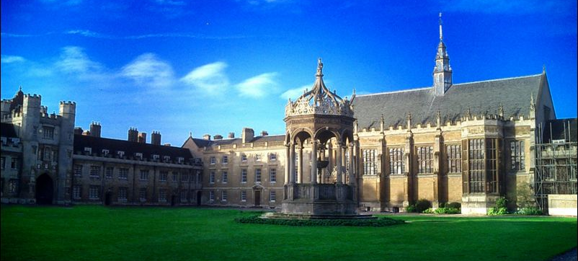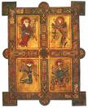
Book Of Kells

Trinity College Dublin is the oldest university in Ireland. Founded in 1592 by Queen Elizabeth I, in the very heart of Ireland's capital Trinity College Dublin sits on a beautiful campus with lots of delightfully historic buildings set amongst the greenery and cobblestones. You can ramble around for a few hours or else seek out heritage attractions including the Book of Kells and The Dublin Experience. Opening Hours: All year round Mon-Sat 9:30 am to 5:30 pm, also Jun- Sep Sun 9:30 am – 4: 30 pm & Oct –May Sun noon- 4:30 pm. Address: Accomodation Office, Trinity College, Dublin City Centre, County Dublin, Dublin 2, Republic Of Ireland.
Temple Bar
Some of Dublin's best night spots, restaurants and unusual shops line these narrow, cobbled streets running between the Bank of Ireland and Christ Church Cathedral. It was also the birthplace of parliamentarian Henry Grattan. Skilled craftsmen and artisans, such as clockmakers and printers, lived and worked around Temple Bar until post-Emergency (post-war) industrialisation led to a decline in the area's fortunes. The area developed an "alternative" identity and a successful lobby by local residents persuaded CIE to drop their plans. As more cynical Dubliners put it, the area became the city's "officially designated arts zone". But while the new investment and planning may have added a slight air of contrivance, it's still an exciting, atmospheric and essentially very young place. Organizations based here include the Irish Film Centre (IFC), the experimental Projects Arts Centre and around a dozen galleries. There are also centres for music, multi-media and photography as well as a Children's Cultural Centre-an arts centre offering theatre, workshops and other entertainment for children

Excursions:
Wicklow
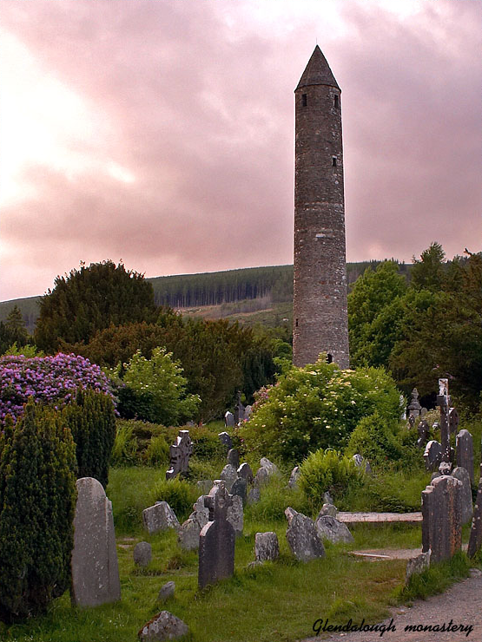

Dublin City is only 12 miles from the County Wicklow border. Wicklow called the Garden County is renowned for its scenery; Hidden around every corner are rich and interesting attractins including the 6th century monastic centre of Glendalough in the Wicklow Mountains National park. Experience the magnificent houses and the gardens such as Powerscourt, Kilruddy, Russborough, Avondale and Mount Usher Gardens which further hightlights the Reputation of the “Garden of Ireland”. Some of the attractions here include Arklow Maritim museum, Glenroe Open Farm, Natioanl Sealife Centre, Powercourt Estate and Waterfall, Clara Lara Fun Park, Wicklow Historic Goal, Baltinglass Abbey, Glendalough Visitors centre and many more.

Top of Form
Kilkenny

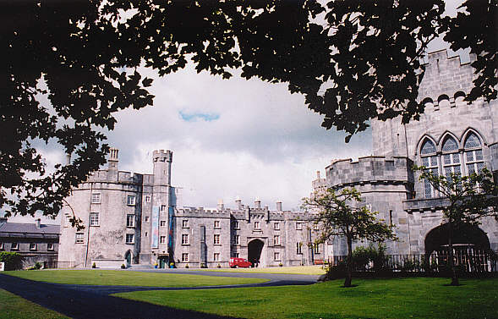
With Ireland’s Medieval capital at its heart, County Kilkenny offeras the South East’s finest countreside, a pretty, rich farmland dotted with medieval ruins, solid stone walls, charming villages and a host of historic monuments including Jerpoint Abbey, one of Ireland’s finest monastic settlements, ancient Kilkenny Castle overlooking River Noore. St. Canice’s cathedral, Rothe House, Kyteler’s Inn and numerous restored historic buildings.

Kildare
Located in the east of Ireland, Kildare County is well known for its love for horses. Sporting, racing and hunting actively take place in this region. Also, some of the best golf clubs of the country can be found here. Visitors can expect to be treated to splendid views of open grasslands, green pastures and ancient bog lands. Castle towns house, Irish National stud and Japanese Gardens are just some of the places that will delight people from anywhere in the world.

Recomended restaurants :
Besfoff’s, Botticelli, Café Kilmore, Elephant and castle & captain America’s.

Indian Restaurants:
Jaipur
Address: 41 South Great Georges Street, Dublin 2

Tulsi near Stephen’s Green
Address: 17A Lr. Baggot Street, Dublin 2

Saagar
Address-: 16 Harcourt Street,
Dublin 2

Belfast

Belfast, the capital of Northern Ireland, meanwhile, is legendary for its excellent nightlife – this is one city that knows how to have a good time. But beyond the pubs, bars and nightclubs, Belfast is also one of Europe’s most exciting city break destinations with critically acclaimed restaurants, smart boutique hotels and top shopping. This beautiful Victorian city has stacks of things to do - you can check out where great ships like Titanic were built, marvel at the architecturally impressive City Hall and Queen’s University, or immerse yourself in Belfast’s sparkling city life.

Getting There
Air: Daily flights link Belfast’s two airports with the four London airports - Heathrow, Gatwick, Luton and Stansted.
Daily scheduled flights also operate from most British regional airports, the Republic of Ireland, and other European cities.
George Best Belfast City Airport 3 miles away from City centre
Rail link to Great Victoria Street Station in the city centre.
A regular Airlink bus service operates into the city centre.
Belfast International Airport at Aldergrove is 30 minutes drive.
A regular Airbus service operates into the city centre.
Sea: Sea crossing from both Scotland and England.
High-speed catamaran or by traditional ferry (90 minutes).

Getting Around:

Citybus provides local bus service within the city.
Taxis are available at all main rail stations, ports, and airports, and in front of City Hall.
Belfast is a good city for walking.

Attractions

Aunt Sandra’s Candy Factory

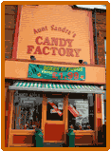

Welcome to Aunt Sandra’s candy factory. Step into the past with a visit to Aunt Sandra's Candy Factory and see candy making as it used to be. All candy made by hand, some to traditional recipes over 100 years old. Opening Hours
Monday - Friday 9.30am - 5pm and Saturday: 10am - 4.30pm
Aunt Sandra's Candy Factory, 60 Castlereagh Road, Belfast, BT5 5FP

Sheridan Imax Cinema
Sheridan IMAX Cinema, Ireland's only 3D and 2D large format cinema has arrived at Odyssey. The IMAX Experience offers the most advanced and compelling film experience in the world. IMAX features a screen taller than four double-decker buses and a six channel surround sound system with over forty speakers. The 373-tiered seating auditorium ensures everyone has a complete view of the screen and provides wheelchair access. The crystal clear images fill the viewer's peripheral vision creating the impression of being at the centre of the on-screen action whether climbing the world's tallest mountains, exploring its deepest oceans or travelling through space. Location- Odyssey Pavilion, 2 Queens Quay, and Box Office: 028 9046 7000 Belfast, BT3 9QQ. E-mail: info@belfastimax.com

Whowhatwherewhenwhy(W5)

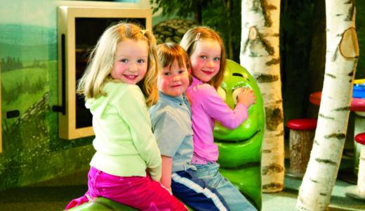
W5 is a world-class interactive discovery centre and is located at Odyssey in the heart of Belfast. The centre has over 160 amazing interactive exhibits which are housed in five action packed exhibition areas – WOW, START, GO, SEE & DO. Attractions including a lie detector, laser harp, building bridges, a giant racetrack, robot building plus lots more. W5 offers an ever-changing programme of special events, shows and temporary exhibitions.W5’s location, on the bank of the River Lagan, at Odyssey, the Northern Ireland Millennium Landmark Project, provides spectacular views of Belfast and the River and is only a short walk from Belfast City Centre. Opening times: Open daily: Mon-Sat 10 am-6 pm; Sun noon-6 pm (last admission 5 pm)
During term time closes 1 hour earlier Mon-Thurs.

Belfast City Hall

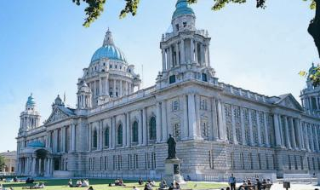
City Hall stands in the centre of Donegal Square in the Heart of Belfast. Dominates the City's principal shopping area, covering an acre and half. Designed by Alfred Brumwell Thomas, the home of Belfast City Council, built in Portland stone, Belfast City Hall was completed in 1906. A magnificent Edwardian "wedding cake" built to reflect Belfast City's status, granted by Queen Victoria in 1888. The dome is 53m (173 feet) high. The City Hall encouraging and promoting the Commerce and Arts of the City". Public and private tours are available. Leaflets about the building and gardens are available at the City Hall. Opening times: All year Mon - Fri 11am, 2pm & 3pm, Sat 2pm & 3pm
no tours on Bank/Public Holidays or Sundays.
Duration 45 minutes

St Anne’s Cathedral

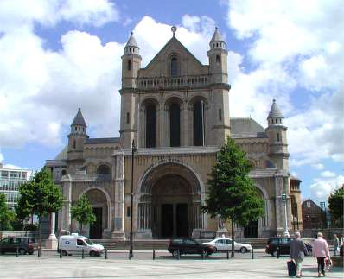

A hallmark of the Irish neo-Romanesque style -- marks this large edifice, which is basilica and was built at the turn of the 20th century. Lord Carson (1854-1935), who was largely responsible for keeping the six counties inside the United Kingdom, is buried here beneath a suitably austere grey slab. New landscaping around the Anglican cathedral provides a perch to rest your feet in good weather. Opening Hours: Daily 10:00 to 4:00

The Odyssey Arena
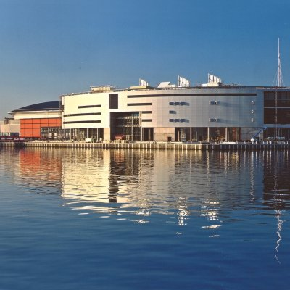

The Odyssey Arena is the showpiece of Northern Ireland's Landmark Millennium Project situated in Queen's Island. Odyssey complex is Northern Ireland's Largest Indoor Venue and features the home the Belfast Giants ice hockey team, W5, an interactive science and technology center, Sheridan IMAX® theater and the Sheridan Pavilion featuring bars, restaurants, shops and the Warner Village Cinemas multiplex with 12 screens. The area is now known as the Titanic Quarter.
The Odyssey Arena is easily accessible to all people. The Arena is superbly located in the heart of the city, close to three motorways, five minutes from the nearest airport and 15 minutes walk from Central station.
Belfast Castle
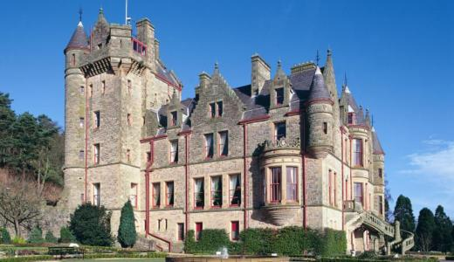
Belfast Castle occupies a prominent site on the slopes of Cave Hill, some 400 ft above sea level. This magnificent sandstone building, now managed by Belfast City Council, has close associations with the city’s past. Its sense of history, the superb setting and the new, refurbished visitor centre makes Belfast Castle a ‘must’ for every visitor. Public tours are held at various times throughout the year however a private tour can be arranged at any time (depending on numbers). Please contact reception for further details. Opening times : Mon-Sun: 9am - 10.30pm, tours on request. Visitors must check with reception.

Antrim

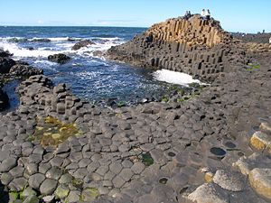
County Antrim forms the north-east corner of Northern Ireland, about 3 kilometers (2 miles) north of the town of Bushmills. It was declared a World Heritage Site by UNESCO in 1986; it is very famous for The Giant's Causeway is an area of about 40,000 interlocking basalt columns, the result of an ancient volcanic eruption. It is the most popular tourist attraction in Northern Ireland.

Indian Restaurants

Café India
Address: 42/46 Malone Road, Belfast

The Spice Club
Address: Ramada Hotel, Shaws Bridge, Belfast

Gingeroot
Address: 73-75 Great Victoria Street, Belfast

Cork
Cork without doubt is the hottest city breaks in Ireland. As well as lively and charming port city of Cork., there is beautiful mountain scenery, peaceful lakes and coastlines of spectacular cliffs, and beaches.

Getting there:
There are daily ferry services between Swansea in the UK to Cork.
Cork International airport receives flights from many international destinations and other cities in Ireland.

Getting around:
By foot as Cork is a small city centre.
Buses: Most buses leave from the main street, Patrick’s Street or the near by bus station at Parnell Place.

Attractions

Cork has famous golf courses like the Waterville Ballybunion. The regions most magnificent buildings are the Muckross House located in the Lakes of Killarney.

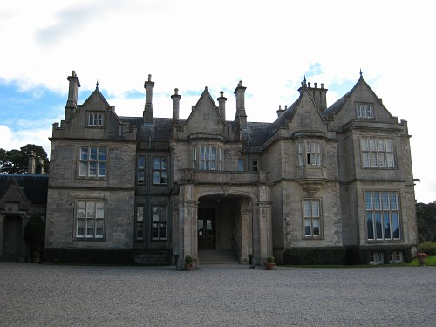

Muckross House

Blarney:
Blarney is 8 km from Cork City is set in a beautiful wooded countryside. Steeped in history and magical charm, Blarney village offers the visitor a host of wonderful things to do and places to discover. Some great sights to visit include the legendary Blarney Stone at Blarney Castle. Tradition holds that those who kiss the Blarney stone will be endowed with the gift of eloquence – “the gift of Gab”.

Indian Restaurants
Bombay Palace
Address – 14-15 Cook Street, Cork

Indian Palace
Address – 31 Princess Street, Cork

The New Maharajah
Address – 19 Cook Street, Cork

Galway
Known as the city of tribes. Galway is famous for its Beach Resort Salt hill, Music, festivals, horse racing, pubs, restaurants, shops, theatres.

Attractions:

National Children’s Discovery Museum
The first of many visiting exhibits planned for Ireland's first ever Children's Discovery Museum arrived yesterday. Designed to be educational, playful, but above all, inspirational, Leonardo: The Marriage of Art and Technology is a collection of interactive machines based on Leonardo Da Vinci's original sketches. Each machine has moving parts, and children can learn about the science and art of Leonardo through playful discovery of his inventions. Conveniently located within walking distance of Galway Racecourse and with café facilities on site, the museum offers a great break from the hustle and bustle of the track for all the family. A museum designed for children under 12. It is open seven days a week during the summer from 10.00am to 17.00pm with late openings Thursday and Fridays until 19.00pm.

Ireland’s National Aquarium.

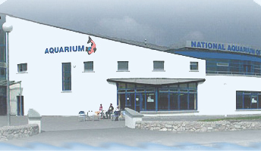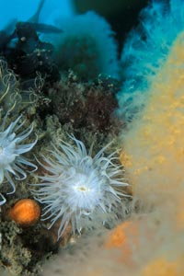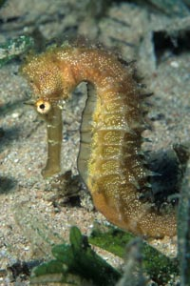

An enjoyable and educational environment in which to learn about the diverse marine ecosystem in Ireland. As Ireland’s National Aquarium, we are home to the country’s largest display of marine and fresh water life. Below are just samples of the creatures we exhibit. To discover more go to our Species page above, or better still, come visit us and see all 150 species for real! Opening hours- Monday To Friday: 9am to 5pm Saturday and Sunday
9am to 6pm.We are open 7 days a week for the Spring and Summer. We close some Mondays and Tuesdays from November to February for essential tank maintenance

Connemara National Park
Situated near Letterfrack, the Park covers some 2,000 hectares (4,942 acres) of scenic countryside, rich in wildlife, on the slopes of the Twelve Bens. Attractions include exhibitions, nature trails, audio-visual show. In addition there is a summer programme of walks, talks and special events for younger visitors. Opening hours 9:30 – 18:30- Visit Length Grounds open all year round. Last admission 45 minutes before closing. 2hr 30min.

Other Upcoming Destinations

Waterford:
The county of Waterford is a choice for a day trip for its Crystal works, fully equipped with visitor centre and tour facilities. Other key attractions are the Waterford Museum of Treasure, City Hall and the Christ Church catherdral.

Limerick
Limerick city is sited on one of Europe’s finest rivers, the River Shannon. Key attractions are: King John’s castle and the magnificent Hunt Museum in the Limerick’s Custom House, Bunratty castle, towns like Castleconnell, Killmallock .

Killarney
Killarney is a beautiful town located in the county of Kerry. The Ring of Kerry is very famous here. Tralee and Killarney, and a railway line stretches from the Tralee to Killarney and the East. Some of the attractions here are Cool Wood Park, Killarney national Park, Muckross Estate.

Indian restaurants
Tulsi
Address: Buttermilk Walk, Middle St., Galway

Kashmir
Address: Kilderry House, Lower Fairhill Road, Galway

Shama
Address: Flood Street, Galway

